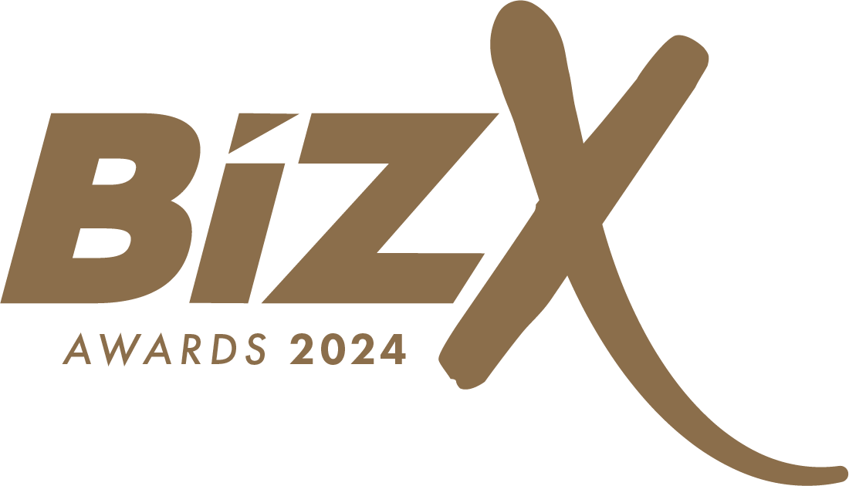

Best Customer Service

Award Entry Questionnaire

Submit this form via email to: info@thebizx.co.uk

IMPORTANT: A valid entry must include all of the following documentation.
☐ A fully completed entry form with all required information (*) completed
☐ Maximum 10 pages of appendices for supporting information (optional)
☐ A high-resolution company logo (.jpg, .eps, .pdf, .ai., .png)

About Your Organisation:

*Contact Person Submitting this Entry:

*Name of Company:
*Email:

*Country:

*Phone:

*Do you currently work with an Action Coach?
Yes ☐ No ☐
*If yes, who is your coach?

- What systems and processes exist to promote ongoing Customer Service improvement across the organisation? (Maximum 600 words)

- What processes exist to optimise employee participation in the development of excellence in Customer Service? (Maximum 600 words)

- How does the current performance of your organisation compare with its history and other similar organisations? (Maximum 600 words)

- Please provide any notable public headlines/testimonials your company has received over the past 3 years. (Maximum 600 words)

- Why should your business win the Best Customer Service award? What would winning this award mean to you and your business? (Maximum 600 words)

- Please provide any customer testimonials you have relating to your customer service. (Maximum 600 words)

- Please state your annual revenue for the past 2 years and how much it has grown?

 | 2022 (£) | 2022 (%) | 2023 (£) | 2023 (%)
Revenue
Profit

- Is this the first time you have attended The BizX?
☐ Yes
☐ No In what year(s)? H ______

- How did you hear about The BizX?
☐ Facebook ☐ Twitter
☐ Direct Website ☐ ActionCOACH
☐ Magazine/Newspaper ☐ Referred by a friend
☐ Other H __________

- Will you be bringing any team or family members?
☐ Yes How many? H ______ ___
☐ No

How to submit your entries
Submit this form via email to: info@thebizx.co.uk
OR by mail c/o ActionCOACH Broadlands Manor, Peckleton Lane, Leicester Forest West, LE9 9QU
Disposition of Entries
Entries and materials submitted may or may not be used, displayed, shown, duplicated, published or disposed of as BizX Forums & Awards deems appropriate. We hold no responsibility to return any documents, images, or files, once submitted to us. By submitting entries, the entrant agrees to hold BizX Forums & Awards and its employees and/or sponsors exempt from any costs or expenses of any claim arising out of any such use by us. Winners must be present at the Awards Ceremony to receive their awards.
Entry Deadline
The entry deadline is 5pm on Thursday 15th February 2024.
Entries received past the stated deadline will be ineligible.

How to Get Help
Need answers to your questions on how to prepare and/or submit your entries?

Visit our web site at: thebizx.co.uk
If you can’t find the answer there, please contact us at:
Telephone: 01284 701 648
Email: info@thebizx.co.uk

